How to log on to Members Only page.
- Access the pc4quality.org/ website.
- Click on the “Members Area” tab.
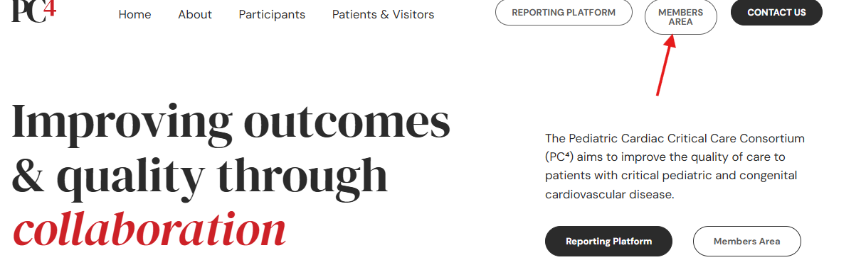

- Enter your email address and password.
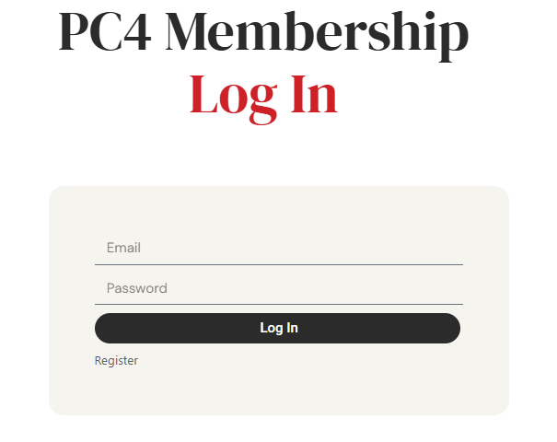

- Click categories to the left for content.
