If there is a need to disallow posts created in sub-categories to be shown in the parent category, do the following:

- Go to the Category management dashboard 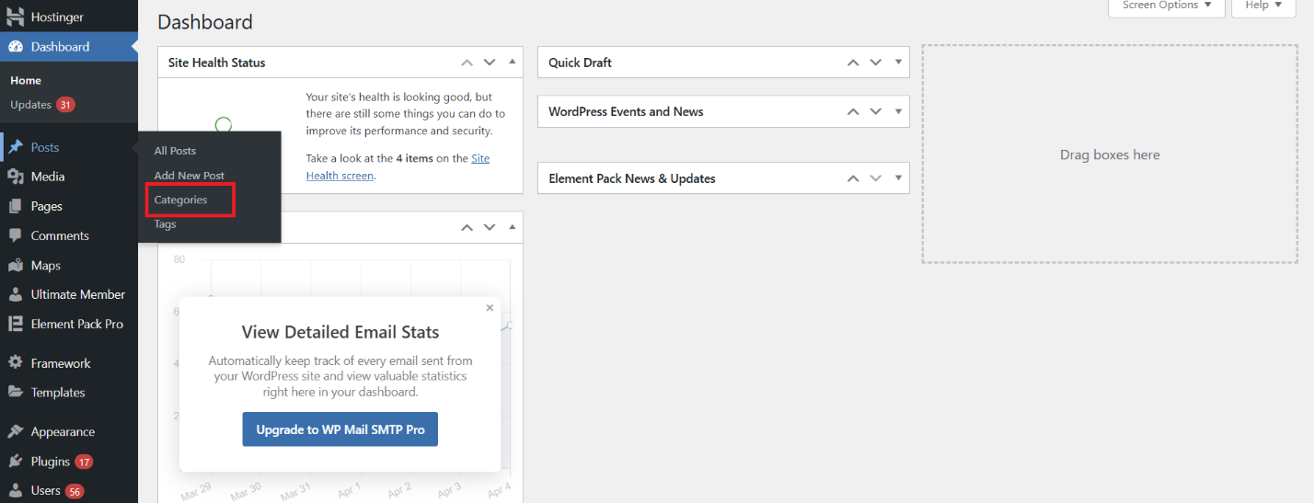
- Select the sub-category you want to unlink from the parent category (for this example, let it be “2024” sub-category)
- Click on Parent Category and select None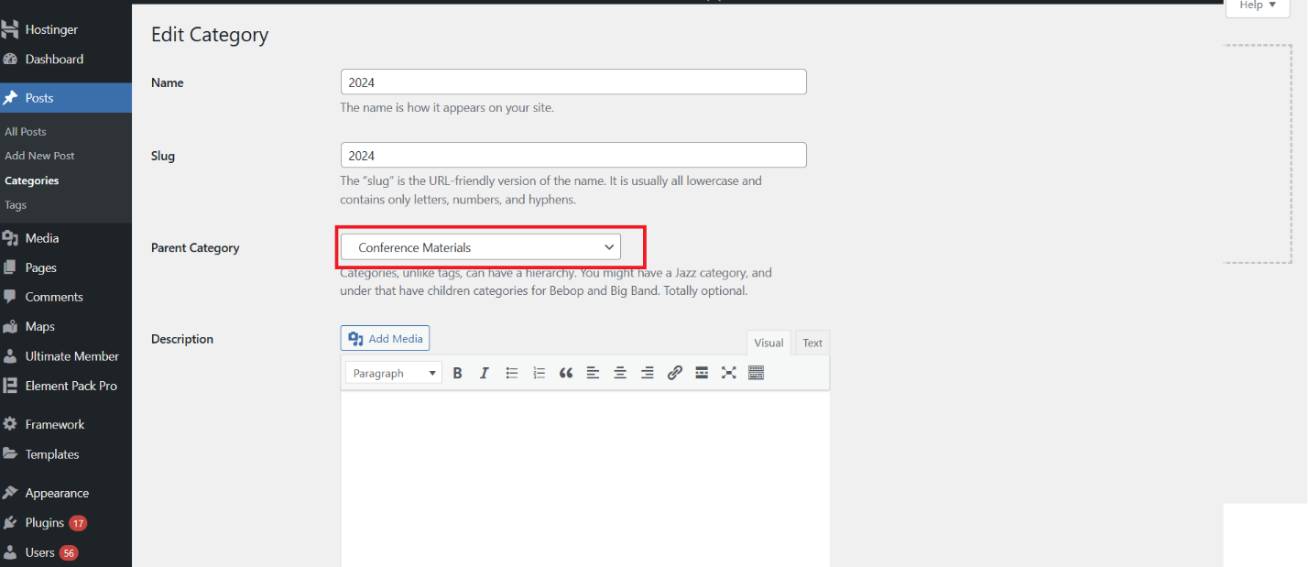
- Click Update down below

