Password Reset Request:
Send an email to pc4.website.team@umich.edu with the subject line password reset.
______________________________________________________________________________________________

How to change user password on Members Only Page
- Access the www.pc4.quality.org website.
- Click on the “Members Area” tab.
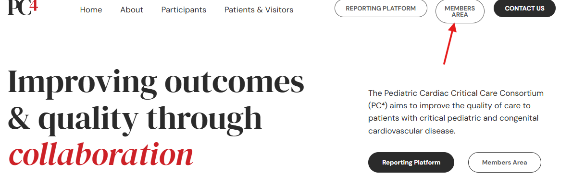

- Enter your email address and assigned password.
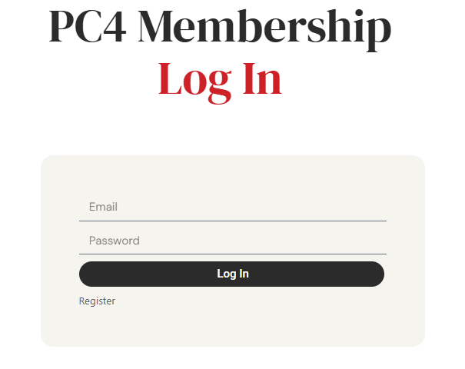

- Click on your username in upper right corner.
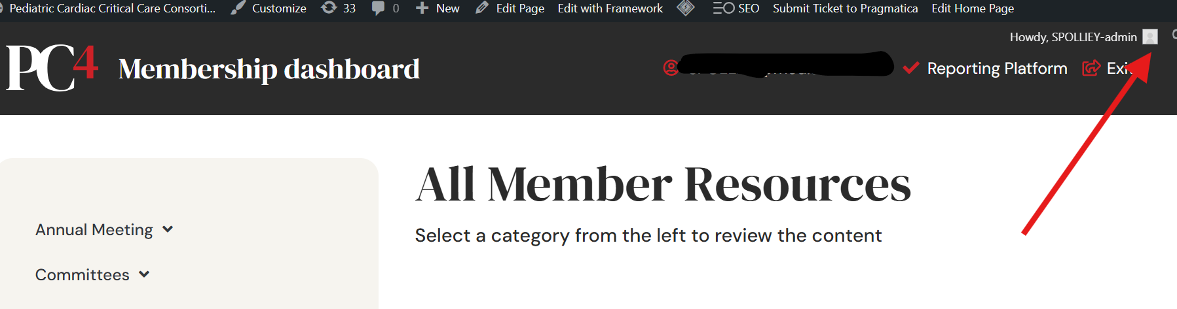

- Click “Edit Profile”
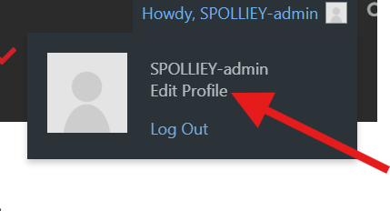

- Scroll to bottom of page under Account Management. Click “Set New Password”
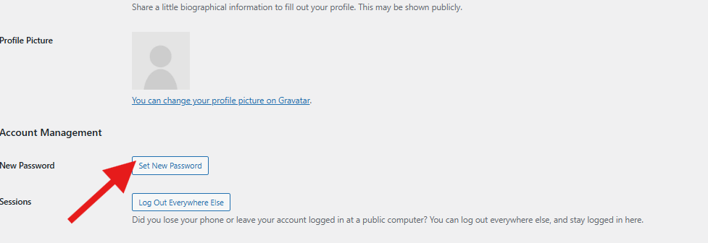
- Remove pre-populated password and enter your own unique password. Click Update Profile to save new password.
