Add/Edit Hospital
- Go to pages.
- Click on Participants and hit edit with framework.
- In upper right corner of hospital column list there is pencil icon (not shown). Click on this to edit icon list.
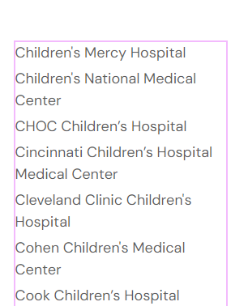

- On left side of screen, this box will appear.
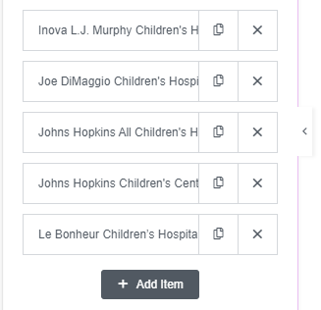
- Click Add Item box
This box will appear.
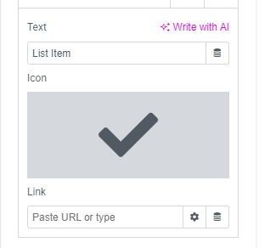
6. Type Hospital name in “List Item” box and paste Hospital website into “Paste URL or Type” box.
7. Click and scroll where you want to put the hospital name. (ex. Alphabetical order)
8. Hover over gray box with check mark and a trash can icon will appear. Click on icon to remove check mark and click “Publish” button at the bottom of the screen.
To edit do same steps as above, but do not click add item.
On the left side of screen, click hospital you want to edit. Change hospital name or URL here and then click “Publish”
