To add a new participating hospital

- Go to Admin Dashboard - Maps - PC⁴ Participating Hospitals
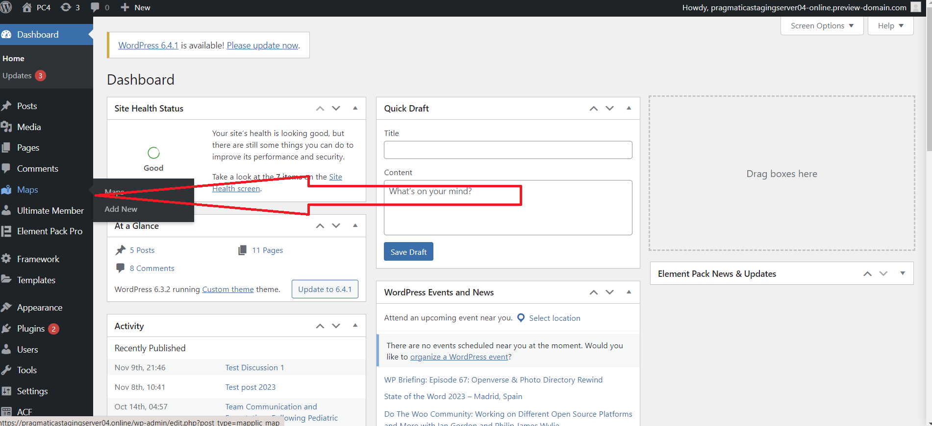
- Click Add New on the right sidebar.
- Enter the following information:
Title (required)
ID (required): this is any unique word or letter combination
Select Floor (USA, Canada or Global)(required)
Select Marker (Must be selected red colored circular border)(required)
Select distinctive Base color
Add a link
- Click Add on the top
- Click Save Changes in the map area
- 